# Model Review Summary

|  |  |  |  |  |  |  |  |  |  |  |
| --- | --- | --- | --- | --- | --- | --- | --- | --- | --- | --- |
|  |  |  |  |  |  |  |  |  |  |  |
|  |  |  |  |  |  |  |  |  |  |  |
|  |  |  |  |  |  |  |  |  |  |  |
|  |  |  |  |  |  |  |  |  |  |  |
|  |  |  |  |  |  |  |  |  |  |  |
|  |  |  |  |  |  |  |  |  |  |  |
|  |  |  |  |  |  |  |  |  |  |  |

## Model Name:  SS-Direct

**Equation:**  Bi,t+1 = Bi,t + riBi,t(1 - Bi,t/Ki) - Ci,t  
  
B = Biomass  
r = Growth Rate  
K = Carrying Capacity  
C = Catch  
  
**Estimated Parameters:**

|  |  |
| --- | --- |
| **Initial Absolute Biomass:** |  |
| Blue_whiting | 5606397.34 |
| Capelin | 4504051.63 |
| Green_halibut | 1204940.46 |
| Haddock | 87236.66 |
| Long_rough_dab | 1050553.23 |
| Mackerel | 4756859.26 |
| North_atl_cod | 3439319.83 |
| Norwegian_ssh | 2414728.70 |
| Polar_cod | 2443745.89 |
| Redfish | 1895533.75 |
| Saithe | 2817649.83 |
| **Growth Rate:** |  |
| Blue_whiting | 0.444 |
| Capelin | 0.685 |
| Green_halibut | 0.154 |
| Haddock | 0.360 |
| Long_rough_dab | 0.118 |
| Mackerel | 0.258 |
| North_atl_cod | 1.131 |
| Norwegian_ssh | 0.287 |
| Polar_cod | 0.065 |
| Redfish | 0.218 |
| Saithe | 0.164 |
| **Carrying Capacity:** |  |
| Blue_whiting | 9761173.55 |
| Capelin | 4686698.50 |
| Green_halibut | 1435337.54 |
| Haddock | 1448829.65 |
| Long_rough_dab | 1631891.42 |
| Mackerel | 5628973.71 |
| North_atl_cod | 6979399.68 |
| Norwegian_ssh | 3586988.71 |
| Polar_cod | 4546196.03 |
| Redfish | 3684474.82 |
| Saithe | 17208014.71 |

### Biomass plots

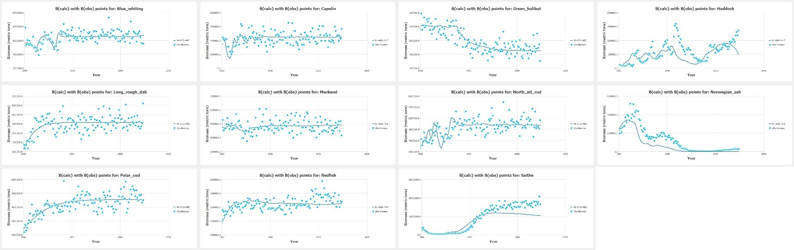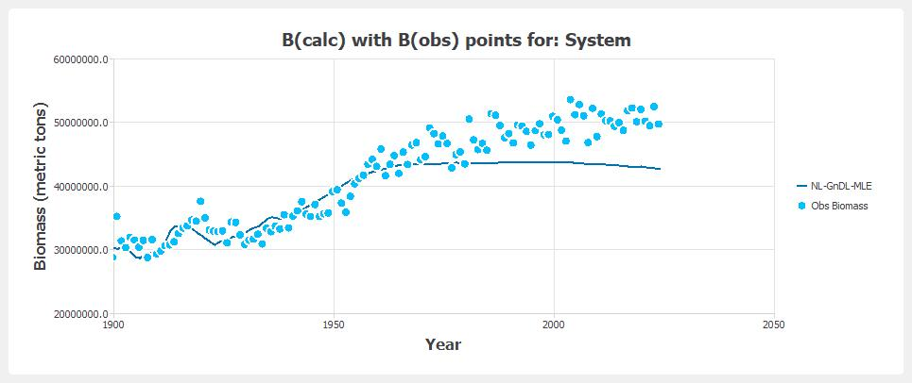

### Model Fit Summary

|  |  |  |  |  |  |  |  |  |  |  |  |  |
| --- | --- | --- | --- | --- | --- | --- | --- | --- | --- | --- | --- | --- |
| Statistic | Blue_whiting | Capelin | Green_halibut | Haddock | Long_rough_dab | Mackerel | North_atl_cod | Norwegian_ssh | Polar_cod | Redfish | Saithe | Model |
| SSresiduals | 8.296E+13 | 9.76E+13 | 1.201E+12 | 1.392E+13 | 2.929E+12 | 2.573E+13 | 6.181E+13 | 8.353E+13 | 2.847E+13 | 2.567E+13 | 1.478E+15 | 1.901E+15 |
| SSdeviations | 3.146E+13 | 4.613E+13 | 2.924E+12 | 7.805E+12 | 1.712E+12 | 1.616E+12 | 4.255E+13 | 1.811E+14 | 3.675E+13 | 8.267E+12 | 2.934E+15 | 3.294E+15 |
| SStotals | 1.144E+14 | 1.437E+14 | 4.125E+12 | 2.172E+13 | 4.641E+12 | 2.734E+13 | 1.044E+14 | 2.646E+14 | 6.522E+13 | 3.394E+13 | 4.412E+15 | 5.196E+15 |
| r² | 0.275000 | 0.321000 | 0.709000 | 0.359000 | 0.369000 | 0.059000 | 0.408000 | 0.684000 | 0.564000 | 0.244000 | 0.665000 | 0.423000 |
| r | 0.467000 | 0.424000 | 0.812000 | 0.447000 | 0.600000 | 0.209000 | 0.493000 | 0.883000 | 0.743000 | 0.280000 | 0.942000 | 0.573000 |
| AIC | 3408.633000 | 3428.943000 | 2879.265000 | 3185.474000 | 2990.665000 | 3262.276000 | 3371.844000 | 3409.484000 | 3274.928000 | 3262.020000 | 3768.616000 | 3294.741000 |
| RMSE | 814665.625000 | 883610.917000 | 98033.156000 | 333666.278000 | 153071.292000 | 453660.963000 | 703186.392000 | 817441.444000 | 477210.682000 | 453196.082000 | 3.438E+06 | 784178.770000 |
| RI | 1.138000 | 1.252000 | 1.106000 | 1.989000 | 1.101000 | 1.097000 | 1.150000 | inf | 1.119000 | 1.148000 | 1.779000 | inf |
| AE | -90294.272000 | -3061.822000 | 12101.657000 | -93572.783000 | -785.171000 | -5309.051000 | 1081.209000 | -509495.849000 | -4868.144000 | 5406.975000 | -1531833.336000 | -201875.508000 |
| AAE | 619367.342000 | 727558.069000 | 77817.740000 | 250777.636000 | 122971.512000 | 360139.059000 | 556902.603000 | 571378.275000 | 370104.913000 | 360498.293000 | 2.626E+06 | 603916.188000 |
| MEF | 0.203000 | 0.134000 | 0.640000 | 0.080000 | 0.359000 | 0.042000 | 0.174000 | 0.632000 | 0.552000 | -0.005000 | 0.758000 | 0.324000 |

## *Model Name:  SS- RandMultirun

**Equation:**  Bi,t+1 = Bi,t + riBi,t(1 - Bi,t/Ki) - Ci,t  
  
B = Biomass  
r = Growth Rate  
K = Carrying Capacity  
C = Catch  
Estimated Parameters:

|  |  |
| --- | --- |
| **Initial Absolute Biomass:** |  |
| Blue_whiting | 4994094.57 |
| Capelin | 3118189.59 |
| Green_halibut | 1204940.46 |
| Haddock | 87236.66 |
| Long_rough_dab | 1050553.23 |
| Mackerel | 4971239.51 |
| North_atl_cod | 3439319.84 |
| Norwegian_ssh | 2414728.65 |
| Polar_cod | 2394377.29 |
| Redfish | 1895533.75 |
| Saithe | 2820149.23 |
| **Growth Rate:** |  |
| Blue_whiting | 0.444 |
| Capelin | 0.648 |
| Green_halibut | 0.154 |
| Haddock | 0.360 |
| Long_rough_dab | 0.054 |
| Mackerel | 0.129 |
| North_atl_cod | 1.131 |
| Norwegian_ssh | 0.287 |
| Polar_cod | 0.070 |
| Redfish | 0.183 |
| Saithe | 0.164 |
| **Carrying Capacity:** |  |
| Blue_whiting | 9836377.97 |
| Capelin | 4873607.00 |
| Green_halibut | 1435337.54 |
| Haddock | 1448829.65 |
| Long_rough_dab | 1693692.44 |
| Mackerel | 6802319.98 |
| North_atl_cod | 6978193.35 |
| Norwegian_ssh | 3586990.40 |
| Polar_cod | 4526743.96 |
| Redfish | 3772922.30 |
| Saithe | 17208014.73 |

### Biomass plots

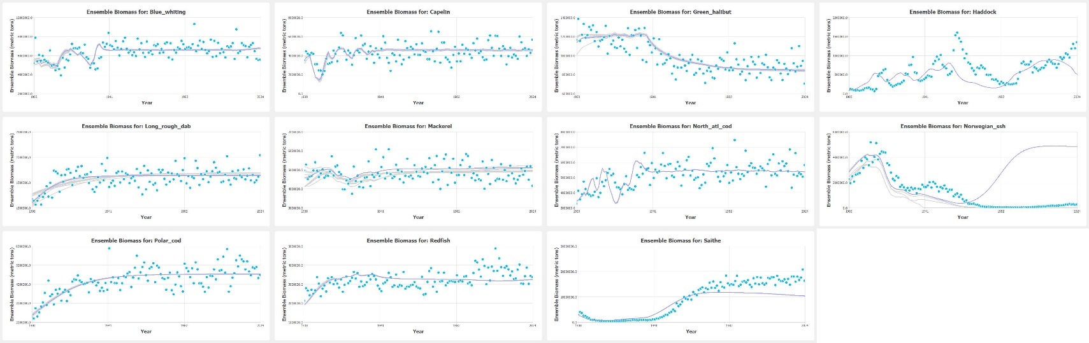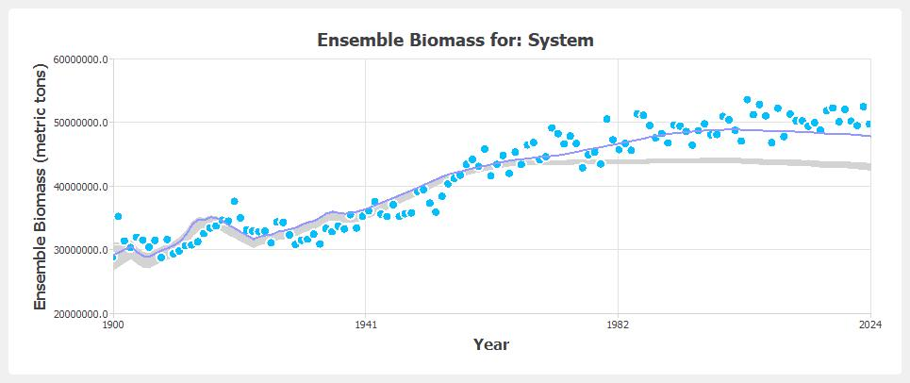

### Model Fit Summary

|  |  |  |  |  |  |  |  |  |  |  |  |  |
| --- | --- | --- | --- | --- | --- | --- | --- | --- | --- | --- | --- | --- |
| Statistic | Blue_whiting | Capelin | Green_halibut | Haddock | Long_rough_dab | Mackerel | North_atl_cod | Norwegian_ssh | Polar_cod | Redfish | Saithe | Model |
| SSresiduals | 8.44E+13 | 9.826E+13 | 1.308E+12 | 1.392E+13 | 2.974E+12 | 2.987E+13 | 6.182E+13 | 9.024E+14 | 2.864E+13 | 2.617E+13 | 1.482E+15 | 2.732E+15 |
| SSdeviations | 3.378E+13 | 5.057E+13 | 2.87E+12 | 7.805E+12 | 1.587E+12 | 6.202E+12 | 4.471E+13 | 6.257E+14 | 3.85E+13 | 9.234E+12 | 2.931E+15 | 3.752E+15 |
| SStotals | 1.182E+14 | 1.488E+14 | 4.178E+12 | 2.172E+13 | 4.562E+12 | 3.607E+13 | 1.065E+14 | 1.528E+15 | 6.714E+13 | 3.54E+13 | 4.413E+15 | 6.483E+15 |
| r² | 0.286000 | 0.340000 | 0.687000 | 0.359000 | 0.348000 | 0.172000 | 0.420000 | 0.409000 | 0.573000 | 0.261000 | 0.664000 | 0.411000 |
| r | 0.455000 | 0.432000 | 0.794000 | 0.447000 | 0.592000 | 0.173000 | 0.499000 | -0.087000 | 0.742000 | 0.280000 | 0.942000 | 0.479000 |
| AIC | 3410.779000 | 3429.790000 | 2889.908000 | 3185.474000 | 2992.585000 | 3280.949000 | 3371.876000 | 3706.974000 | 3275.675000 | 3264.400000 | 3768.978000 | 3325.217000 |
| RMSE | 821687.659000 | 886609.565000 | 102296.605000 | 333666.310000 | 154251.648000 | 488842.033000 | 703274.595000 | 2.687E+06 | 478638.428000 | 457531.928000 | 3.443E+06 | 959718.022000 |
| RI | 1.139000 | 1.254000 | 1.110000 | 1.989000 | 1.102000 | 1.107000 | 1.150000 | 20.226000 | 1.119000 | 1.150000 | 1.781000 | 3.012000 |
| AE | -71307.921000 | 54041.620000 | 13185.800000 | -93563.616000 | 5589.713000 | 155840.022000 | 4049.787000 | 1.449E+06 | -8915.731000 | -4447.931000 | -1535617.500000 | -2953.509000 |
| AAE | 619189.960000 | 733608.408000 | 80611.758000 | 250779.257000 | 124085.211000 | 404568.865000 | 557766.955000 | 2.004E+06 | 372377.964000 | 363664.992000 | 2.629E+06 | 740054.619000 |
| MEF | 0.189000 | 0.128000 | 0.608000 | 0.080000 | 0.349000 | -0.112000 | 0.174000 | -2.980000 | 0.550000 | -0.025000 | 0.757000 | -0.026000 |

## Model Name:  Schaefer-Pred-Direct

**Equation:**  Bi,t+1 = Bi,t + riBi,t(1 - Bi,t/Ki) - Ci,t - Bi,t∑ρi,jBj,t  
  
B = Biomass  
r = Growth Rate  
K = Carrying Capacity  
C = Catch  
ρi,j = Predation Coefficient for Predator Species j on Prey Species i  
  
**Estimated Parameters:**

|  |  |  |  |  |  |  |  |  |  |  |  |
| --- | --- | --- | --- | --- | --- | --- | --- | --- | --- | --- | --- |
| **Initial Absolute Biomass:** |  |  |  |  |  |  |  |  |  |  |  |
| Blue_whiting | 5548993.97 |  |  |  |  |  |  |  |  |  |  |
| Capelin | 4491219.58 |  |  |  |  |  |  |  |  |  |  |
| Green_halibut | 1107410.69 |  |  |  |  |  |  |  |  |  |  |
| Haddock | 104684.00 |  |  |  |  |  |  |  |  |  |  |
| Long_rough_dab | 1080816.08 |  |  |  |  |  |  |  |  |  |  |
| Mackerel | 4752889.26 |  |  |  |  |  |  |  |  |  |  |
| North_atl_cod | 2936495.30 |  |  |  |  |  |  |  |  |  |  |
| Norwegian_ssh | 2860056.67 |  |  |  |  |  |  |  |  |  |  |
| Polar_cod | 2441003.20 |  |  |  |  |  |  |  |  |  |  |
| Redfish | 2106148.61 |  |  |  |  |  |  |  |  |  |  |
| Saithe | 2827345.80 |  |  |  |  |  |  |  |  |  |  |
| **Growth Rate:** |  |  |  |  |  |  |  |  |  |  |  |
| Blue_whiting | 0.448 |  |  |  |  |  |  |  |  |  |  |
| Capelin | 0.913 |  |  |  |  |  |  |  |  |  |  |
| Green_halibut | 0.147 |  |  |  |  |  |  |  |  |  |  |
| Haddock | 0.360 |  |  |  |  |  |  |  |  |  |  |
| Long_rough_dab | 0.114 |  |  |  |  |  |  |  |  |  |  |
| Mackerel | 0.259 |  |  |  |  |  |  |  |  |  |  |
| North_atl_cod | 1.728 |  |  |  |  |  |  |  |  |  |  |
| Norwegian_ssh | 0.287 |  |  |  |  |  |  |  |  |  |  |
| Polar_cod | 0.066 |  |  |  |  |  |  |  |  |  |  |
| Redfish | 0.206 |  |  |  |  |  |  |  |  |  |  |
| Saithe | 0.164 |  |  |  |  |  |  |  |  |  |  |
| **Carrying Capacity:** |  |  |  |  |  |  |  |  |  |  |  |
| Blue_whiting | 10226500.83 |  |  |  |  |  |  |  |  |  |  |
| Capelin | 5010410.49 |  |  |  |  |  |  |  |  |  |  |
| Green_halibut | 1664783.04 |  |  |  |  |  |  |  |  |  |  |
| Haddock | 1448890.40 |  |  |  |  |  |  |  |  |  |  |
| Long_rough_dab | 1907591.46 |  |  |  |  |  |  |  |  |  |  |
| Mackerel | 5627400.87 |  |  |  |  |  |  |  |  |  |  |
| North_atl_cod | 7039668.75 |  |  |  |  |  |  |  |  |  |  |
| Norwegian_ssh | 3561868.29 |  |  |  |  |  |  |  |  |  |  |
| Polar_cod | 4547599.65 |  |  |  |  |  |  |  |  |  |  |
| Redfish | 3954731.02 |  |  |  |  |  |  |  |  |  |  |
| Saithe | 21326880.90 |  |  |  |  |  |  |  |  |  |  |
| **Predation (rho):** |  |  |  |  |  |  |  |  |  |  |  |
|  | Blue_whiting | Capelin | Green_halibut | Haddock | Long_rough_dab | Mackerel | North_atl_cod | Norwegian_ssh | Polar_cod | Redfish | Saithe |
| Blue_whiting | 0.000e+00 | 0.000e+00 | 2.974e-10 | 0.000e+00 | 0.000e+00 | 0.000e+00 | 2.586e-12 | 0.000e+00 | 0.000e+00 | 1.714e-09 | 0.000e+00 |
| Capelin | 1.634e-09 | 0.000e+00 | 0.000e+00 | 2.597e-09 | 2.446e-09 | 0.000e+00 | 3.145e-08 | 1.903e-11 | 0.000e+00 | 0.000e+00 | 6.379e-10 |
| Green_halibut | 0.000e+00 | 0.000e+00 | 0.000e+00 | 0.000e+00 | 0.000e+00 | 0.000e+00 | 1.336e-10 | 0.000e+00 | 0.000e+00 | 0.000e+00 | 0.000e+00 |
| Haddock | 0.000e+00 | 0.000e+00 | 0.000e+00 | 1.413e-13 | 0.000e+00 | 0.000e+00 | 4.839e-11 | 0.000e+00 | 0.000e+00 | 5.370e-12 | 3.570e-11 |
| Long_rough_dab | 0.000e+00 | 0.000e+00 | 0.000e+00 | 3.196e-10 | 0.000e+00 | 0.000e+00 | 3.654e-10 | 0.000e+00 | 0.000e+00 | 0.000e+00 | 0.000e+00 |
| Mackerel | 0.000e+00 | 0.000e+00 | 6.780e-11 | 0.000e+00 | 0.000e+00 | 0.000e+00 | 0.000e+00 | 0.000e+00 | 0.000e+00 | 0.000e+00 | 0.000e+00 |
| North_atl_cod | 0.000e+00 | 0.000e+00 | 1.022e-09 | 5.790e-10 | 5.892e-10 | 0.000e+00 | 6.682e-11 | 0.000e+00 | 0.000e+00 | 1.341e-10 | 1.497e-10 |
| Norwegian_ssh | 9.032e-12 | 0.000e+00 | 2.985e-10 | 1.426e-09 | 1.247e-11 | 0.000e+00 | 5.195e-11 | 0.000e+00 | 0.000e+00 | 0.000e+00 | 4.435e-10 |
| Polar_cod | 0.000e+00 | 0.000e+00 | 0.000e+00 | 0.000e+00 | 2.694e-10 | 0.000e+00 | 8.865e-11 | 0.000e+00 | 0.000e+00 | 0.000e+00 | 0.000e+00 |
| Redfish | 1.810e-09 | 0.000e+00 | 8.671e-10 | 0.000e+00 | 0.000e+00 | 0.000e+00 | 8.865e-12 | 0.000e+00 | 0.000e+00 | 0.000e+00 | 0.000e+00 |
| Saithe | 0.000e+00 | 0.000e+00 | 0.000e+00 | 0.000e+00 | 0.000e+00 | 0.000e+00 | 0.000e+00 | 0.000e+00 | 0.000e+00 | 6.523e-12 | 0.000e+00 |

### Biomass plots

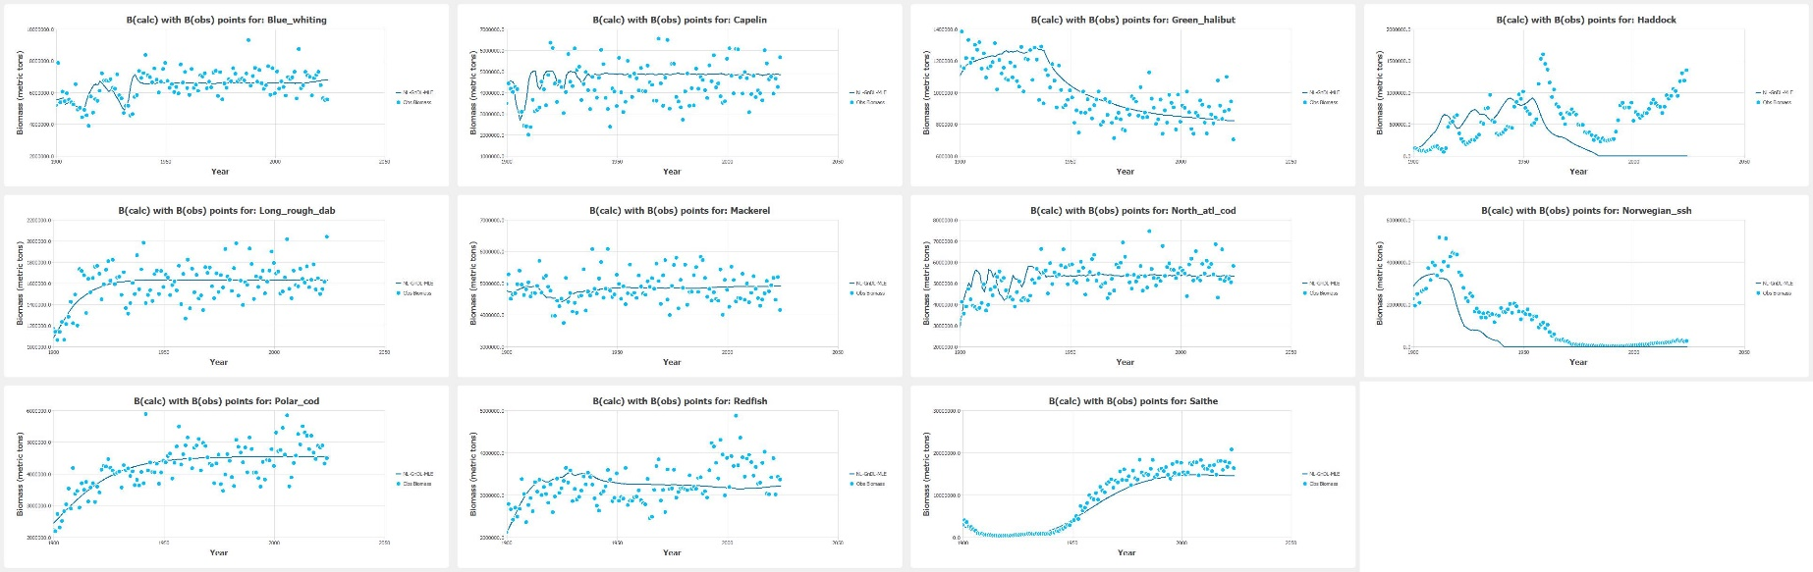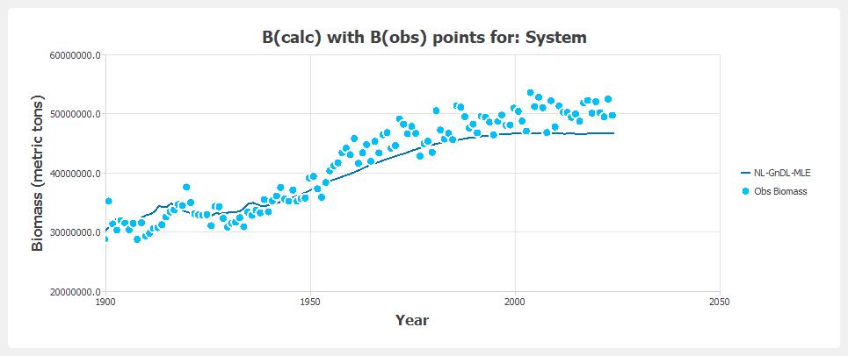

### Model Fit Summary

|  |  |  |  |  |  |  |  |  |  |  |  |  |
| --- | --- | --- | --- | --- | --- | --- | --- | --- | --- | --- | --- | --- |
| Statistic | Blue_whiting | Capelin | Green_halibut | Haddock | Long_rough_dab | Mackerel | North_atl_cod | Norwegian_ssh | Polar_cod | Redfish | Saithe | Model |
| SSresiduals | 8.194E+13 | 1.286E+14 | 1.758E+12 | 3.765E+13 | 2.941E+12 | 2.573E+13 | 7.074E+13 | 1.151E+14 | 2.847E+13 | 2.644E+13 | 4.489E+14 | 9.683E+14 |
| SSdeviations | 3.181E+13 | 4.502E+13 | 3.634E+12 | 2.015E+13 | 1.621E+12 | 1.615E+12 | 1.901E+13 | 2.084E+14 | 3.668E+13 | 6.476E+12 | 4.347E+15 | 4.721E+15 |
| SStotals | 1.138E+14 | 1.736E+14 | 5.392E+12 | 5.78E+13 | 4.562E+12 | 2.735E+13 | 8.975E+13 | 3.235E+14 | 6.515E+13 | 3.292E+13 | 4.795E+15 | 5.689E+15 |
| r² | 0.280000 | 0.259000 | 0.674000 | 0.349000 | 0.355000 | 0.059000 | 0.212000 | 0.644000 | 0.563000 | 0.197000 | 0.906000 | 0.409000 |
| r | 0.471000 | 0.317000 | 0.762000 | -0.086000 | 0.597000 | 0.209000 | 0.316000 | 0.826000 | 0.743000 | 0.217000 | 0.985000 | 0.487000 |
| AIC | 3409.089000 | 3465.387000 | 2928.836000 | 3311.875000 | 2993.178000 | 3264.301000 | 3390.717000 | 3451.571000 | 3276.962000 | 3267.695000 | 3621.691000 | 3307.391000 |
| RMSE | 809648.450000 | 1.014E+06 | 118579.927000 | 548805.597000 | 153386.139000 | 453705.698000 | 752281.695000 | 959613.066000 | 477274.646000 | 459907.189000 | 1.895E+06 | 694764.262000 |
| RI | 1.137000 | 1.285000 | 1.127000 | inf | 1.101000 | 1.097000 | 1.160000 | inf | 1.119000 | 1.149000 | 1.522000 | inf |
| AE | -47926.175000 | 459136.331000 | 32287.276000 | -246079.387000 | 1801.962000 | -5927.510000 | 92449.996000 | -586708.792000 | -247.122000 | 5245.140000 | -1001608.339000 | -117961.511000 |
| AAE | 613877.197000 | 840552.222000 | 93788.496000 | 454832.974000 | 123132.436000 | 360116.249000 | 594220.847000 | 678612.520000 | 370507.078000 | 361904.212000 | 1.426E+06 | 537916.341000 |
| MEF | 0.213000 | -0.141000 | 0.473000 | -1.490000 | 0.357000 | 0.042000 | 0.055000 | 0.492000 | 0.552000 | -0.035000 | 0.926000 | 0.131000 |

## *Model Name:  Schaefer-Pred-RandMultiRun

### Biomass plots

### Model Fit Summary

|  |  |  |  |  |  |  |  |  |  |  |  |  |
| --- | --- | --- | --- | --- | --- | --- | --- | --- | --- | --- | --- | --- |
| Statistic | Blue_whiting | Capelin | Green_halibut | Haddock | Long_rough_dab | Mackerel | North_atl_cod | Norwegian_ssh | Polar_cod | Redfish | Saithe | Model |
| SSresiduals |  |  |  |  |  |  |  |  |  |  |  |  |
| SSdeviations |  |  |  |  |  |  |  |  |  |  |  |  |
| SStotals |  |  |  |  |  |  |  |  |  |  |  |  |
| r² |  |  |  |  |  |  |  |  |  |  |  |  |
| r |  |  |  |  |  |  |  |  |  |  |  |  |
| AIC |  |  |  |  |  |  |  |  |  |  |  |  |
| RMSE |  |  |  |  |  |  |  |  |  |  |  |  |
| RI |  |  |  |  |  |  |  |  |  |  |  |  |
| AE |  |  |  |  |  |  |  |  |  |  |  |  |
| AAE |  |  |  |  |  |  |  |  |  |  |  |  |
| MEF |  |  |  |  |  |  |  |  |  |  |  |  |

# ***************EXTRAS

# Model Name:

## Biomass plots

## Model Fit Summary

|  |  |  |  |  |  |  |  |  |  |  |  |  |
| --- | --- | --- | --- | --- | --- | --- | --- | --- | --- | --- | --- | --- |
| Statistic | Blue_whiting | Capelin | Green_halibut | Haddock | Long_rough_dab | Mackerel | North_atl_cod | Norwegian_ssh | Polar_cod | Redfish | Saithe | Model |
| SSresiduals |  |  |  |  |  |  |  |  |  |  |  |  |
| SSdeviations |  |  |  |  |  |  |  |  |  |  |  |  |
| SStotals |  |  |  |  |  |  |  |  |  |  |  |  |
| r² |  |  |  |  |  |  |  |  |  |  |  |  |
| r |  |  |  |  |  |  |  |  |  |  |  |  |
| AIC |  |  |  |  |  |  |  |  |  |  |  |  |
| RMSE |  |  |  |  |  |  |  |  |  |  |  |  |
| RI |  |  |  |  |  |  |  |  |  |  |  |  |
| AE |  |  |  |  |  |  |  |  |  |  |  |  |
| AAE |  |  |  |  |  |  |  |  |  |  |  |  |
| MEF |  |  |  |  |  |  |  |  |  |  |  |  |

# Model Name:

## Biomass plots

## Model Fit Summary

|  |  |  |  |  |  |  |  |  |  |  |  |  |
| --- | --- | --- | --- | --- | --- | --- | --- | --- | --- | --- | --- | --- |
| Statistic | Blue_whiting | Capelin | Green_halibut | Haddock | Long_rough_dab | Mackerel | North_atl_cod | Norwegian_ssh | Polar_cod | Redfish | Saithe | Model |
| SSresiduals |  |  |  |  |  |  |  |  |  |  |  |  |
| SSdeviations |  |  |  |  |  |  |  |  |  |  |  |  |
| SStotals |  |  |  |  |  |  |  |  |  |  |  |  |
| r² |  |  |  |  |  |  |  |  |  |  |  |  |
| r |  |  |  |  |  |  |  |  |  |  |  |  |
| AIC |  |  |  |  |  |  |  |  |  |  |  |  |
| RMSE |  |  |  |  |  |  |  |  |  |  |  |  |
| RI |  |  |  |  |  |  |  |  |  |  |  |  |
| AE |  |  |  |  |  |  |  |  |  |  |  |  |
| AAE |  |  |  |  |  |  |  |  |  |  |  |  |
| MEF |  |  |  |  |  |  |  |  |  |  |  |  |